My first idea for a project was to compare some story or parable from each of the four gospels. I was interested in seeing how each of the books differed in how they told the story. I looked up a list of stories that were in all four gospels online, and the story that I decided to look at was the resurrection of Jesus after his crucifixion. Before writing a program to help me, I decided to read through each of the stories to see what I wanted to focus on. While looking at the four different texts, I noticed something interesting. Each of the stories have mention of an angel, waiting at the tomb to tell the women that Jesus has written, except for the narrative in Mark. Mark, instead, mentions a young man in a white robe. I decided to put my initial examination of the difference between the presentations of the resurrection story in each gospel on hold, instead examining each of the gospels for mentions of angels. I wrote up a program in python to help me with this examination.

My first program, angel_check, uses the NLTK toolkit to find each use of a specific word in its context using the concordance function, in this case angel and angels. It also gives a dispersion plot of both of the words. I ran each of the gospels through this program, and examined the output of the program, shown in the [name_of_gospel]angel text files. The results of this are shown in the following *graphs*:

Figure 1: Bar chart showing frequency of angel and angels by gospel book.

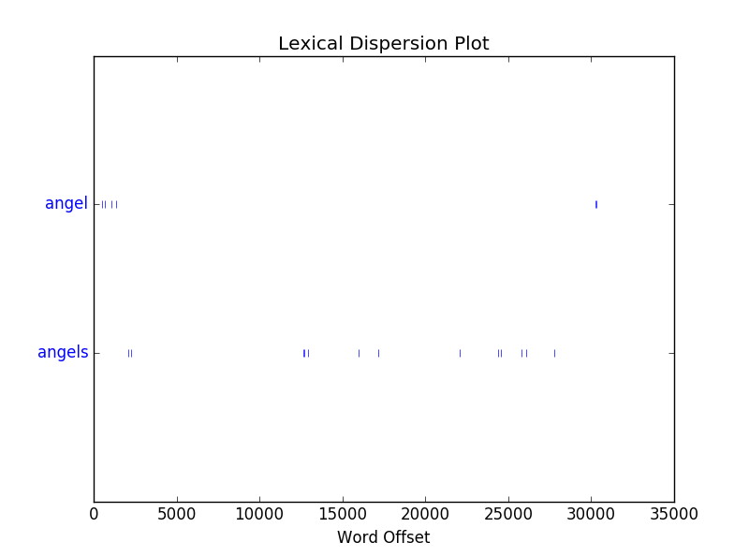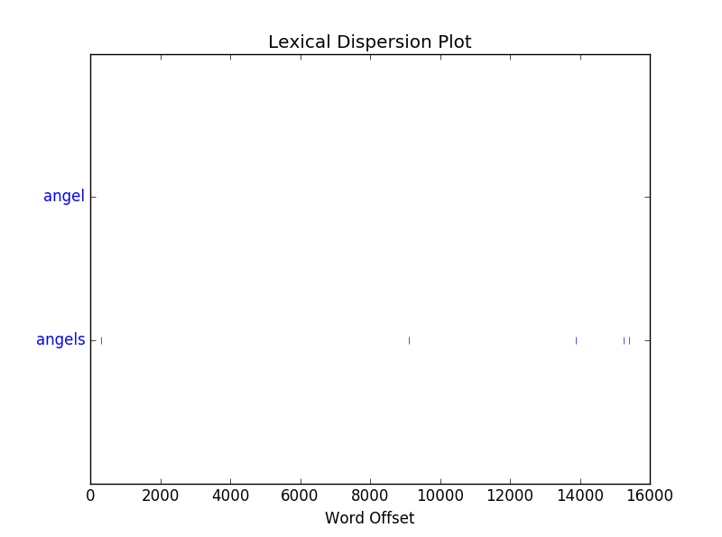

Figure 2: Dispersion Plot for Matthew of angel and angels.

Figure 3: Dispersion Plot for Mark of angel and angels.

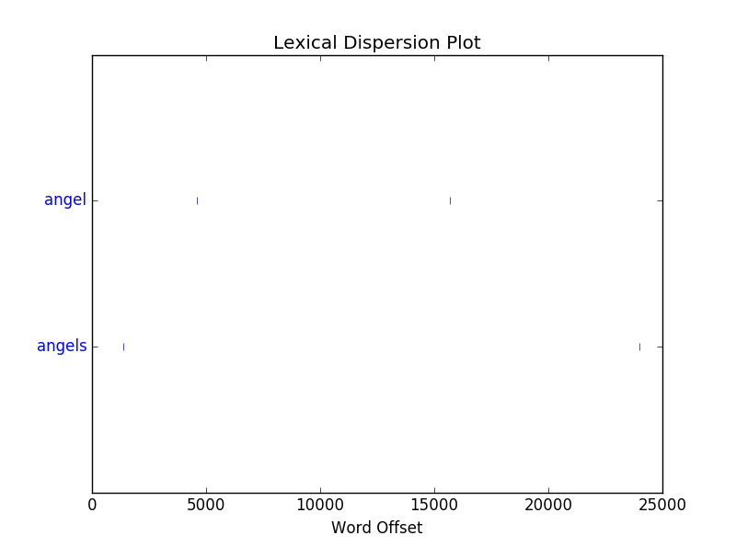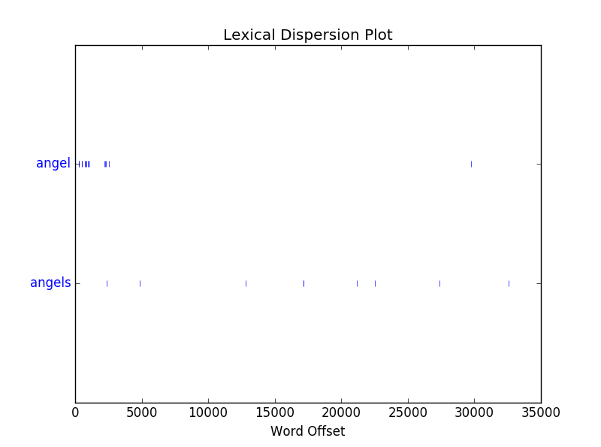

Figure 4: Dispersion Plot for John of angel and angels.

Figure 5: Dispersion Plot for Luke of angel and angels.

It was while looking at the results that I noticed something interesting about Matthew’s usage of angels. Matthew has a decent amount of talking about the end of days and various apocalyptic stuff. A lot of the places where angels appear is in these apocalyptic parts. For example, there are passages like “The harvest is the end of the age, and the reapers are angels” (13:39) and “The angels will come forth and separate the wicked from among the righteous” (13:49). This association between angels and end-of-days ideas is shown in the resurrection story, as it tells of an angel who comes down to roll away the stone in front of the tomb. When the angel arrives, there is a great earthquake, and the guards at the tomb are terrified. This earthquake is symbolic of the apocalyptic background that Matthew gave the angels in his book.

Mark, unlike Matthew, doesn’t talk that much about angels. But when he does, they still show up in apocalyptic ideas. Four of the five uses of the word ‘angels’ are in reference to the end days, or at least to when Jesus will return to being with his father. The one use of angel not in reference to that is in the brief touch upon the 40 days Jesus spent in the wilderness, where Mark says the “angels were serving him.”

Luke uses angels the most out of the four gospels. There was a lot of mentions of angels in the birth narrative from Luke. Luke also has no real reference to the apocalyptic ideas that both Matthew and Mark share, at least in reference to angels. John references angels the least out of the four, and like Luke, none of the references are for apocalyptic ideas.

So now that we have this, we can return to the analysis of the resurrection stories, and what changed for each of the narratives. Mark is generally considered the earliest of the gospels. In it, he details the initial story: women coming to the tomb, learning that Jesus has disappeared, and reporting this to the disciples. Even though Mark does not explicitly use the word angel, his ‘young man’ is most likely an angel.

Matthew adds a bit more, due to his focus on writing to a Jewish audience. The addition of guards at the tomb is to contradict the idea that the disciples removed Jesus’ body.